SideScribe Documentation

Your Web-to-Doc Research Companion.
Streamline your research process by capturing web content and converting it into professional documents instantly.

1. Introduction
SideScribe is a Chrome extension designed for students, researchers, and software engineers. It eliminates the "tab-switching" fatigue by providing a side-panel text editor that stays open while you browse.
Key Features:
- Persistent Sidebar: Work alongside your browser without losing focus.
- One-Click Capture: Highlight text on any website and send it directly to your editor.
- Pro Exporter: Convert your notes into clean .docx, .pdf, or .txt files.
- Theme Support: Seamlessly switch between Light and Dark modes.

2. Installation & Setup
To begin using SideScribe:
- Open the Chrome Web Store.
- Search for SideScribe and click Add to Chrome.
- Click the Extensions icon (puzzle piece) and pin SideScribe for easy access.


3. Using the Editor
Opening the Sidebar
Simply click the SideScribe icon in your toolbar. The editor will slide open on the right side of your screen.
Capturing Web Content
- Highlight any text on a webpage.
- If the Highlight Feature is enabled (check the mouse icon in your header), the text will instantly appear in your SideScribe editor.
- Your progress is saved automatically to your local storage.
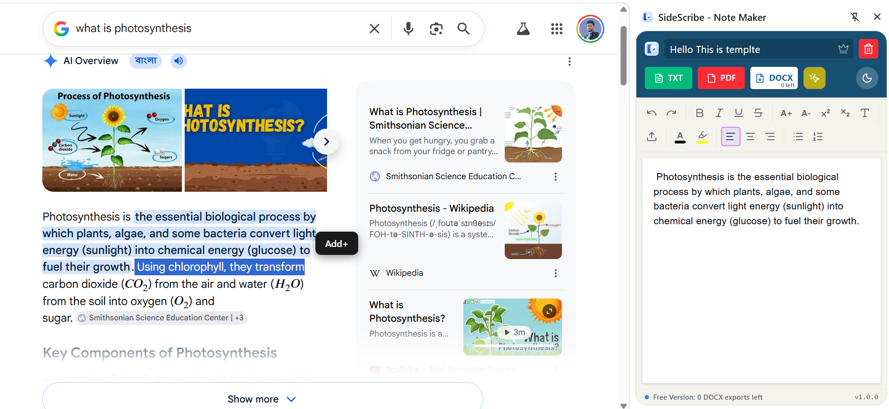

4. The Toolbar & Formatting
SideScribe comes with a full-featured rich text editor toolbar:
Icon | Function
B / I / U | Basic text styling (Bold, Italic, Underline).
A+ / A- | Increase or decrease font size.
Color Picker | Change text color or apply highlights.
Alignment | Left, Center, and Right text alignment.
Lists | Bulleted and Numbered lists for organization.

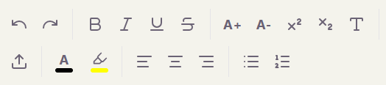

5. Exporting Your Work
Once your research is complete, you can export your document in multiple formats:
- TXT: Best for quick, raw notes.
- PDF: Best for reading and sharing.
- DOCX: Best for further editing in Microsoft Word or Google Docs.


6. SideScribe Pro
Unlock the full power of SideScribe with a lifetime Pro license.
- Unlimited DOCX Exports: Remove the 5-export limit.
- Priority Support: Direct access to the developer for feature requests.
- One-Time Payment: No monthly subscriptions.
How to Activate:
- Click the Crown icon in the header.
- Complete the payment via the secure Razorpay link.
- Copy your unique license key and paste it into the "License Key" field in the app.
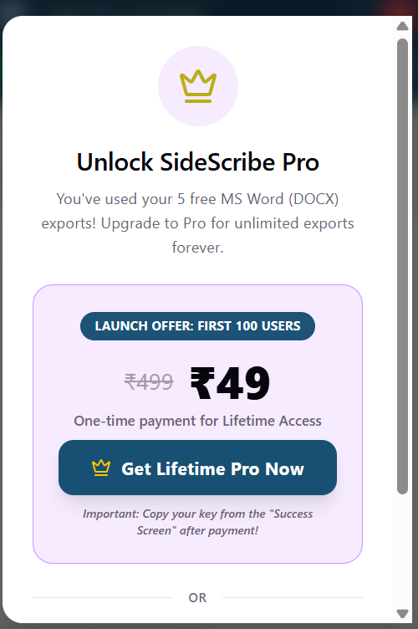

7. Troubleshooting
- Sidebar won't open: Try refreshing the current webpage.
- Formatting looks odd on export: Use the "Clear Formatting" (Type icon) button to reset the text style before exporting.
- Lost work: SideScribe saves to your browser's local storage. Avoid clearing your browser cache if you have unsaved work in the editor.

Developed with ❤️ by Fiaduz Zaman
Support: fiaduzzaman2014@gmail.com

